1.Explain in detail about Broadcast Routing and Multicast Routing.
⭐ 1. Broadcast Routing (GFG Style Explanation)
Broadcast routing is a routing technique in which a packet is delivered to all nodes in a network.
Instead of sending the same packet individually to every destination, the network sends one packet that is replicated as necessary until all nodes receive it.
GeeksforGeeks explains broadcast routing using the following main methods:

⭐ A. Flooding
- Every incoming packet is sent out on all outgoing links, except the one it came from.
- Guarantees delivery to all nodes.
- Uses hop count or sequence numbers to prevent loops.
- Simple but causes high redundancy and network congestion.

⭐ B. Multi-destination Routing
- The packet contains a list of all destinations.
- Routers forward the packet and remove addresses as they deliver.
- Efficient in small networks, but packet header becomes very large.

⭐ C. Spanning Tree Broadcast
- A spanning tree (loop-free subgraph) is formed for the network.
- Packet travels only along tree edges → no duplicates, no loops.
- Efficient and widely used in LANs (e.g., switches use spanning tree protocol).
💡 This is the most efficient broadcast method.

⭐ Applications of Broadcast Routing
- ARP Request (Address Resolution Protocol)
- LAN broadcasts (e.g., DHCP Discover)
- Routing updates in distance-vector protocols

⭐ 2. Multicast Routing (GFG Style Explanation)

Multicast routing delivers packets to a specific group of nodes (multicast group), not to all nodes.
It lies between unicast (one-to-one) and broadcast (one-to-all).
GeeksforGeeks describes multicast as:
“send to a selected group of receivers who are part of a multicast group.”

⭐ Key Concepts in Multicast Routing
A. Multicast Group
- A dynamic group of receivers.
- Nodes can join or leave at any time.
B. Reverse Path Forwarding (RPF)
- A router forwards the packet only if it arrives on the reverse path toward the sender.
- Prevents loops
- Used by many multicast protocols.
C. Multicast Trees
- Source-based Tree
  - A separate tree is formed for each sender.
  - Shortest path from source to all receivers.
  - Efficient but expensive to maintain if many senders exist.
- Group-shared Tree
  - One tree shared by all senders in that multicast group.
  - Core-based trees (CBT) use a central router as a root.
  - Less overhead, easier to manage.

⭐ Common Multicast Routing Protocols
- DVMRP (Distance Vector Multicast Routing Protocol)
- PIM-DM (Protocol Independent Multicast – Dense Mode)
- PIM-SM (Sparse Mode, uses shared trees)
- IGMP (Routers detect multicast group members)

⭐ Broadcast vs Multicast Routing (GFG Style Table)
Feature | Broadcast Routing | Multicast Routing
Targets | All nodes in network | Specific group of nodes
Efficiency | Less efficient (duplicates may occur) | More efficient, selective delivery
Techniques | Flooding, Spanning Tree | RPF, Source-based Tree, Group-shared Tree
Bandwidth Usage | High | Low
Applications | ARP, LAN broadcasts | Video conferencing, IPTV, group messaging

⭐ Final Summary (Write This in Exam)
Broadcast routing sends packets to all nodes using flooding, multi-destination routing, or spanning tree. It is simple but can waste bandwidth.
Multicast routing sends packets to a selected group using techniques like Reverse Path Forwarding, source-based trees, and group-shared trees. It is more efficient and used in applications like video streaming, conferencing, and group communication.
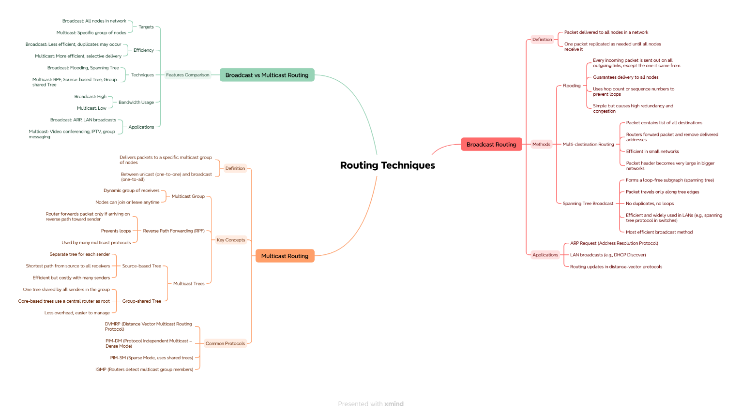

2.Elaborate on Internet Protocol header format.
⭐ IPv4 Datagram Header — 10 Marks Summary
IPv4 (Internet Protocol Version 4) is a connectionless, packet-switched network protocol that uses 32-bit addressing, providing about 4.3 billion unique addresses. IPv4 addresses are written in dot-decimal notation (e.g., 192.168.1.5). It supports unicast, broadcast, and multicast communication and allows network configuration using manual methods or DHCP. An IPv4 datagram consists of a header and data, and the header contains essential information for routing, delivery, and fragmentation.
The IPv4 datagram header has a minimum size of 20 bytes and a maximum of 60 bytes due to optional fields. It contains 12 main fields:

⭐ Fields of IPv4 Datagram Header
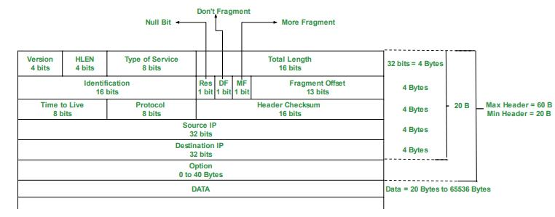
1. Version (4 bits)
Indicates the IP version. For IPv4, the value is 4.
2. Header Length (HLEN – 4 bits)
Specifies the header size in 32-bit words. Minimum = 5 words (20 bytes), Maximum = 15 words (60 bytes).
3. Type of Service (8 bits)
Indicates service parameters like low delay, high throughput, or high reliability.
4. Total Length (16 bits)
Size of the entire datagram (header + data). Range: 20 to 65,535 bytes.
5. Identification (16 bits)
A unique number assigned to each packet to help in reassembling fragments.
6. Flags (3 bits)
Control fragmentation.
- Bit 0: Reserved
- Bit 1: Do Not Fragment (DF)
- Bit 2: More Fragments (MF)
7. Fragment Offset (13 bits)
Specifies the position of a fragment in the original datagram. Expressed in units of 8-byte blocks.
8. Time To Live – TTL (8 bits)
Limits the lifetime of a packet by counting hops. Prevents routing loops.
9. Protocol (8 bits)
Indicates the protocol carried inside the IP packet (e.g., TCP = 6, UDP = 17).
10. Header Checksum (16 bits)
Used for error-checking only the header.
11. Source IP Address (32 bits)
IP address of the sender.
12. Destination IP Address (32 bits)
IP address of the recipient.
13. Options (Variable length, optional)
Used for functions like record route, source route, etc. Increases header size beyond 20 bytes.

⭐ Key Points (Ready to Score Marks)
- IPv4 is a 32-bit, connectionless network protocol.
- Supports unicast, broadcast, multicast, and VLSM.
- Datagram header = minimum 20 bytes, maximum 60 bytes.
- Important fields: Version, HLEN, Type of Service, Total Length, Identification, Flags, Fragment Offset, TTL, Protocol, Checksum, Source & Destination IP, Options.
- Fragmentation is supported by both sender and routers.
- TTL avoids looping in networks.

⭐ Final Summary
The IPv4 datagram header contains all essential information for routing, fragmentation, addressing, and delivery. It is compact yet flexible due to options, making IPv4 suitable for a wide range of networks and applications.
3.Discuss elaborately on Subnetting and Super netting.
Below is the perfect, clean, exam-ready 10-mark answer for:
Subnetting and Supernetting
(Written exactly in GeeksforGeeks style — simple, clear, and scoring)

⭐ 1. Subnetting (GFG Style Explanation)
Subnetting is a technique in which a large network (one network ID) is divided into multiple small networks called subnets.
GeeksforGeeks defines subnetting as:
👉 “A method of dividing a network address into smaller logical subnetworks to improve efficiency and security.”
⭐ Why Subnetting Is Needed?
- Efficient use of IP addresses
- Reduces network congestion
- Improves security and management
- Allows separation of departments or locations
- Helps in hierarchical routing

⭐ How Subnetting Works?
IP address = Network ID + Host ID
Subnetting borrows some host bits and uses them as subnet bits.
Example:
A Class C network: 192.168.1.0/24
Borrowing 2 bits → /26
Subnets created:
- 192.168.1.0
- 192.168.1.64
- 192.168.1.128
- 192.168.1.192
Each subnet has 64 addresses.

⭐ Key Terms in Subnetting
- Subnet Mask: Identifies network + subnet portion.
- CIDR Notation: Example /24, /26
- Network Address: First address in subnet
- Broadcast Address: Last address in subnet
- Usable Hosts: 2ⁿ − 2

⭐ Advantages of Subnetting
- Better IP address utilization
- Reduced broadcast traffic
- Improved performance
- Logical separation of networks
- Enhances routing efficiency

⭐ 2. Supernetting (GFG Style Explanation)
Supernetting is the opposite of subnetting.
Instead of dividing a network, supernetting combines multiple smaller networks into a larger one.
GeeksforGeeks defines supernetting as:
👉 “A technique for aggregating multiple network addresses to form a bigger block, mainly used for route aggregation.”
Supernetting is also called CIDR (Classless Inter-Domain Routing).

⭐ Why Supernetting Is Needed?
- Reduces routing table size
- Provides route summarization
- Solves shortage of IPv4 addresses
- Used by ISPs to allocate blocks

⭐ How Supernetting Works?
Example:
Combine four Class C networks:
- 192.168.4.0
- 192.168.5.0
- 192.168.6.0
- 192.168.7.0
Common prefix length = /22
So one supernet is formed:
👉 192.168.4.0/22
This single route replaces 4 separate routes.

⭐ Characteristics of Supernetting
- Combines continuous (contiguous) networks
- Requires reducing subnet mask (e.g., /24 → /22)
- Reduces routing overhead
- Used for ISP-level address management

⭐ Advantages of Supernetting
- Smaller routing tables
- Faster routing lookups
- Efficient address allocation
- Reduces memory usage in routers

⭐ Subnetting vs Supernetting (GFG Style Table)
Feature | Subnetting | Supernetting
Definition | Dividing a network into smaller subnets | Combining multiple networks into one larger net
Goal | Better IP utilization, reduce traffic | Route summarization, reduce routing tables
Mask | Subnet mask becomes longer (e.g., /24 → /26) | Mask becomes shorter (e.g., /24 → /22)
Operation | Borrowing host bits | Merging contiguous networks
Used in | Internal LAN design | ISP-level routing, internet backbone
Purpose | Increase subnets | Increase host count / reduce routes

⭐ Final Exam Summary (10 Marks)
Subnetting divides a large network into multiple smaller networks by borrowing host bits and creating subnets. It helps in efficient IP usage, reduces broadcast traffic, and improves security.
Supernetting combines multiple small networks into a large block to reduce routing table entries, support route aggregation, and improve scalability. It uses CIDR notation and is mainly used by ISPs for address allocation.
Both techniques are essential for efficient IPv4 network management.

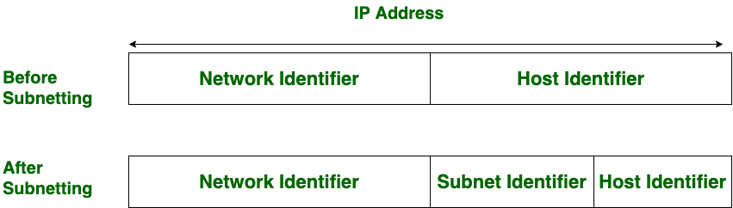
4.Explain the concept of congestion. How many ways congestion can be handled in network.
Below is the perfect exam-ready 10-mark answer for:
Explain the Concept of Congestion. How Many Ways Congestion Can Be Handled in a Network?
(Answer written in GeeksforGeeks style—clear, simple, and scoring.)

⭐ 1. Concept of Congestion
Congestion in a network occurs when too many packets are present in the network at the same time, causing the network load to exceed its capacity.
This results in:
- Long delays
- Packet loss
- Buffer overflows
- Reduced throughput
- Retransmissions
- Network performance breakdown
In short:
👉 Congestion happens when “demand > network resources.”
Congestion usually occurs due to:
- High traffic load
- Slow or overloaded routers
- Limited buffer capacity
- Low bandwidth links
- Bursty traffic patterns

⭐ 2. Ways to Handle Congestion in a Network
Congestion can be handled in two major ways:
⭐ A. Congestion Prevention (Before Congestion Occurs)
These techniques try to avoid congestion from happening.
1. Admission Control
The network refuses new connections when it is already near capacity.
2. Traffic Shaping (Leaky Bucket / Token Bucket)
Controls the rate at which packets enter the network.
- Leaky Bucket: Fixed output rate
- Token Bucket: Allows bursts of data
3. Packet Scheduling
Routers schedule packets fairly.
Examples:
- FIFO
- Priority Queues
- Round Robin
- Weighted Fair Queuing
4. Load Shedding
Dropping low-priority packets before congestion becomes severe.
5. Resource Reservation
Protocols like RSVP reserve bandwidth in advance to avoid overload.

⭐ B. Congestion Control (After Congestion Occurs)
These techniques try to reduce congestion once the network is overloaded.
1. Retransmission Control
Avoids unnecessary retransmissions that worsen congestion.
2. Window-Based Flow Control (TCP Congestion Control)
TCP uses:
- Slow Start
- Congestion Avoidance
- Fast Retransmit
- Fast Recovery
These adjust the sending rate based on network feedback.
3. Choke Packets
Routers send a special choke packet to the sender, instructing it to slow down.
4. Explicit Congestion Notification (ECN)
Routers mark packets instead of dropping them.
Receiver signals sender to slow down.
5. Hop-by-Hop Backpressure
A congested router tells the upstream router to slow down, preventing overload.

⭐ 3. Summary (Write This in Exam for Full Marks)
Congestion occurs when the number of packets in a network is greater than the network’s capacity, causing delays, packet loss, and reduced performance. Congestion can be managed in two main ways: Preventing congestion (admission control, traffic shaping, resource reservation, packet scheduling) and controlling congestion after it occurs (TCP congestion control, choke packets, ECN, backpressure, retransmission control). Together, these mechanisms ensure efficient, stable network communication.
Sure! Below are full-length, 10-mark exam answers for Q5, Q6, and Q7, written in GeeksforGeeks style, clean, detailed, and scoring.
You can write them exactly as provided.

⭐ **5. Explain the following routing algorithms:
i) Distance Vector Routing
ii) Hierarchical Routing**
(10 Marks)
Routing algorithms are used to determine the best path for forwarding packets in a network. Two major routing algorithms are Distance Vector and Hierarchical Routing.

⭐ i) Distance Vector Routing
Distance Vector Routing is a dynamic and distributed routing algorithm where each router maintains and updates a table (vector) of distances to all possible destinations.
⭐ Working Principle
- Each router stores a routing table containing:
  - Destination
  - Distance (metric such as hop count)
  - Next-hop router
- Routers periodically exchange their tables with direct neighbors only.
- After receiving updates, each router applies the Bellman-Ford algorithm:
New Distance = Minimum (Cost to Neighbor + Neighbor's Cost to Destination)
⭐ Key Features
- Periodic Updates: Routing information is shared at regular intervals.
- Neighbor-Based Updates: Only immediate neighbors exchange tables.
- Simple Implementation: Easy to configure and maintain.
- Count-to-Infinity Problem: Incorrect routes take long to correct.
- Slow Convergence: Network recovery after failure is slow.
⭐ Example Protocol
- RIP (Routing Information Protocol) uses hop count up to 15.

⭐ ii) Hierarchical Routing
Hierarchical routing is used to make routing scalable in very large networks by dividing the network into layers (hierarchies).
⭐ Concept
- Routers are grouped into regions.
- Each region may be divided into subregions (levels).
- A router stores detailed routes within its own region, but only summarized routes for other regions.
⭐ Working
- Network is divided into levels:
  - Level-1: Routing within a region
  - Level-2: Routing between regions
- Routing tables become smaller because routers handle only a portion of the network.
- Reduces overhead, improves scalability, and speeds up lookup.
⭐ Advantages
- Reduced routing table size
- More efficient bandwidth use
- Faster computation
- Supports millions of routers (like the Internet)
⭐ Examples
- The Internet uses hierarchical routing through Autonomous Systems (AS).
- OSPF uses Area-Based Hierarchical Routing.

⭐ Conclusion (10-mark summary)
Distance Vector Routing is simple and neighbor-based but suffers from loops and slow convergence. Hierarchical Routing divides the network into multiple levels, reduces table size, improves scalability, and is essential for large-scale networks like the Internet.

⭐ 6. Explain congestion control in datagram subnets. (10 Marks)
Congestion occurs when the number of packets entering the network is greater than the capacity of routers and links to handle them, leading to delays, packet drops, and performance degradation.
Datagram networks (like IP networks) handle packets independently, so congestion control mechanisms are essential.

⭐ Types of Congestion Control in Datagram Subnets
There are two categories:
- Open-loop Congestion Control (Prevention)
- Closed-loop Congestion Control (Control after congestion)

⭐ A. Open-loop Congestion Control (Prevention)
These try to prevent congestion before it occurs.
1. Traffic Shaping (Leaky Bucket / Token Bucket)
- Controls the rate at which packets enter the network.
- Leaky Bucket: fixed-rate output
- Token Bucket: allows bursty traffic
2. Admission Control
Network refuses new traffic if it is already near congestion.
Used in QoS networks.
3. Packet Scheduling Algorithms
- FIFO
- Priority Queue
- Fair Queuing
These ensure fair sharing of router resources.
4. Resource Reservation (RSVP)
Bandwidth is reserved for a session to prevent overload.

⭐ B. Closed-loop Congestion Control (After Congestion)
1. Choke Packets
Routers send special packets to the sender to reduce its sending rate.
2. Hop-by-Hop Backpressure
A congested router tells the previous router to slow down, which propagates backward.
3. Implicit Congestion Notification
Sender assumes congestion based on:
- Packet loss
- Timeouts
- Increased delay
4. Explicit Congestion Notification (ECN)
Routers mark packets instead of dropping them.
Receiver notifies the sender to slow down.
5. TCP Congestion Control
Used in IP datagram networks:
- Slow Start
- Congestion Avoidance
- Fast Retransmit
- Fast Recovery
Adjusts sending rate dynamically based on congestion feedback.
6. Load Shedding
Routers drop low-priority packets when overload is severe (Drop-tail, RED).

⭐ Conclusion (10-mark summary)
Congestion control in datagram subnets uses both preventive and corrective measures. Techniques like traffic shaping, scheduling, admission control, choke packets, ECN, and TCP congestion control ensure smooth and efficient data flow even under heavy network load.

⭐ 7. Explain the concept of Classful IP Addressing. (10 Marks)
Classful IP Addressing was the original method used in IPv4 to divide address space into fixed-size classes. It helped identify the network and host portions of an address based on predefined bit boundaries.

⭐ Classes in Classful Addressing
⭐ Class A
- Range: 0.0.0.0 – 127.255.255.255
- First bit: 0
- Network bits: 8
- Host bits: 24
- Very large networks
- Total networks: 128
- Hosts per network: ~16 million

⭐ Class B
- Range: 128.0.0.0 – 191.255.255.255
- First 2 bits: 10
- Network bits: 16
- Hosts per network: 65,534
- Medium-sized enterprise networks

⭐ Class C
- Range: 192.0.0.0 – 223.255.255.255
- First 3 bits: 110
- Network bits: 24
- Hosts per network: 254
- Used for small networks

⭐ Class D (Multicast)
- Range: 224.0.0.0 – 239.255.255.255
- First 4 bits: 1110
- No host bits
- Used for multicasting

⭐ Class E (Experimental)
- Range: 240.0.0.0 – 255.255.255.255
- First 4 bits: 1111
- Reserved for R&D and military

⭐ Characteristics of Classful Addressing
- Fixed network/host boundary
- Network size depends entirely on the class
- Simple addressing format
- No VLSM support
- High wastage of IP addresses
- Replaced by CIDR (Classless Inter-Domain Routing) for efficient allocation

⭐ Advantages
- Very simple to understand
- Easy routing decisions
- Works well for early-stage Internet

⭐ Disadvantages
- Wastage of IP address space
- Inflexible fixed sizes
- Cannot support VLSM
- Scalability issues

⭐ Conclusion (10-mark summary)
Classful IP addressing divides IPv4 addresses into Classes A, B, C for unicast, Class D for multicast, and Class E for research. It uses fixed boundaries, which made routing simple but caused large address wastage, leading to its replacement by CIDR.
Sure! Below are full-length, well-structured, exam-ready 10-Mark answers for Q9, Q10, Q11, Q12 — written in a clear GeeksforGeeks style, exactly suitable for university theory exams.

⭐ 9. Compare the Datagram and Virtual Circuit Networks (10 Marks)
In computer networks, packet switching is implemented using two approaches: Datagram Networks and Virtual Circuit Networks. Both are used for routing packets, but they differ in connection setup, reliability, resource allocation, and router behavior.

⭐ Datagram Networks (Connectionless Networks)
A datagram network uses a connectionless service where each packet is treated independently, without establishing a dedicated path.
⭐ Characteristics
- No Connection Setup:
Packets are sent without establishing a route beforehand.
- Independent Routing:
Each packet may take a different path based on current router decisions.
- No Guaranteed Delivery:
Packets may be lost, duplicated, or arrive out of order.
- Stateless Routers:
Routers do not maintain connection state; only routing tables are stored.
- Variable Delay:
Delay depends on congestion and route chosen.
- Example:
IP (Internet Protocol) is a classic example.

⭐ Virtual Circuit Networks (Connection-oriented Networks)
A virtual circuit (VC) network provides a connection-oriented service where all packets follow a pre-established route.
⭐ Characteristics
- Setup Phase Required:
A path is established before sending data.
- Same Path for All Packets:
Ensures in-order delivery.
- Routers Maintain State:
Each router keeps virtual circuit tables.
- Flow Control & Reliability:
VC networks support congestion and flow control.
- Predictable Delay:
Suitable for real-time applications.
- Examples:
ATM, Frame Relay, MPLS.

⭐ Comparison Table
Feature | Datagram Network | Virtual Circuit Network
Type | Connectionless | Connection-Oriented
Setup Phase | No | Yes
Path | Dynamic, per packet | Fixed for session
Packet Delivery | Out of order possible | In-order guaranteed
Router State | Stateless | Maintains VC tables
Reliability | Handled by end systems | Built-in
Delay | Variable | Predictable
Example | Internet (IP) | ATM, MPLS

⭐ Conclusion
Datagram networks provide flexibility and robustness, whereas virtual circuits provide reliability and predictable performance. The choice depends on application requirements like speed, reliability, and overhead.

⭐ 10. Explain Load Shedding and Jitter Control in Conggestion Control (10 Marks)
Congestion occurs when the number of packets entering the network exceeds its processing capacity. Two important techniques to maintain network performance are Load Shedding and Jitter Control.

⭐ A. Load Shedding
Load Shedding is a method where routers intentionally drop packets during severe congestion to prevent network collapse.
⭐ Why Load Shedding is Needed?
- Router buffers get full under heavy load.
- Too many packets cause retransmissions, increasing load.
- Critical data can be prioritized.
⭐ How Load Shedding Works
- Drop Tail:
Drop packets when buffer becomes full.
- Random Early Detection (RED):
Start dropping packets before buffer is full to avoid sudden collapse.
- Priority-based Dropping:
High-priority packets (voice/video) are kept, low priority dropped first.
- Adaptive Dropping:
Drop more packets as congestion increases.
⭐ Advantages
- Prevents total network collapse
- Ensures important packets still get delivered
- Simple to implement

⭐ B. Jitter Control
Jitter refers to variations in packet delay. It is harmful for real-time applications like video calls, where packets must arrive at even intervals.
⭐ Causes of Jitter
- Network congestion
- Traffic bursts
- Queuing delays
- Variable routing paths
⭐ Jitter Control Techniques
- Jitter Buffers:
Packets are stored briefly to smooth out delay variations.
- Traffic Shaping (Token/Leaky Bucket):
Controls outgoing rate to reduce variation.
- Priority Queuing:
Real-time data gets high priority.
- Resource Reservation (RSVP):
Guarantees required bandwidth.
- Fixed Routing:
Avoids path changes during a session.

⭐ Conclusion
Load shedding handles severe congestion by dropping lower priority packets, while jitter control ensures smooth real-time transmission. Together, they maintain network performance under heavy load.

⭐ 11. Explain with an Example the 5 Phases of Link State Routing Algorithm (10 Marks)
(Link State Routing — used in OSPF)
Link State Routing (LSR) is a dynamic routing algorithm where each router builds a complete map of the network and computes the shortest path using Dijkstra’s algorithm. It operates in five clearly defined phases.
We use an example network:
A—B—C—D (connected line), with costs:
A-B = 2, B-C = 1, C-D = 3.

⭐ Phase 1: Discovering Neighbors
Each router identifies directly connected neighbors using HELLO packets.
Example:
A discovers B; B discovers A and C.

⭐ Phase 2: Measuring Link Costs
Cost is calculated using:
- Bandwidth
- Delay
- Congestion
Example:
A→B = cost 2
B→C = cost 1
C→D = cost 3

⭐ Phase 3: Creating Link State Packets (LSPs)
Each router creates an LSP containing:
- Router ID
- List of neighbors
- Link costs
Example LSP for B:
B → A (2), C (1)

⭐ Phase 4: Flooding LSPs to All Routers
Routers flood LSPs to all neighbors until every router has all LSPs.
Example:
B sends LSP → C → D → A.
Every router now has the same link-state database.

⭐ Phase 5: Computing Shortest Paths (Dijkstra’s Algorithm)
Each router runs the shortest path algorithm independently.
Example from A:
Destination | Path | Cost
B | A → B | 2
C | A → B → C | 3
D | A → B → C → D | 6

⭐ Conclusion
The five phases ensure fast convergence and accurate routing. Each router builds a full view of the network and selects shortest paths efficiently.

⭐ 12. Write General Principles of Congestion Control and Explain the Leaky Bucket Algorithm (10 Marks)
Congestion control ensures that the network does not get overloaded. It keeps network load under safe limits using preventive and corrective mechanisms.

⭐ A. General Principles of Congestion Control
⭐ 1. Monitoring Network Performance
Routers monitor queue lengths, packet delay, and loss.
⭐ 2. Providing Feedback to Senders
Feedback may be:
- Implicit: delay, timeout
- Explicit: choke packets, ECN
⭐ 3. Controlling Incoming Traffic
Traffic shaping techniques (Leaky Bucket, Token Bucket) are used.
⭐ 4. Scheduling Packets
Routers use fair and priority-based scheduling:
- FIFO
- Priority Queue
- Weighted Fair Queuing
⭐ 5. Resource Allocation
Allocates bandwidth and buffer fairly among flows.
⭐ 6. Load Shedding
Drops low-priority packets when overload becomes severe.
⭐ 7. End-to-End Congestion Control
Protocols like TCP use:
- Slow Start
- Congestion Avoidance
- Fast Retransmit
- Fast Recovery

⭐ B. Leaky Bucket Algorithm (Traffic Shaping)
The Leaky Bucket algorithm enforces a constant output rate, preventing traffic bursts from entering the network.

⭐ Working Principle
- Packets enter a bucket (queue) at variable rates.
- Bucket leaks (sends packets) at a fixed, constant rate.
- If bucket overflows → extra packets are discarded.

⭐ Detailed Working Steps
- Bucket has a fixed size (e.g., 10 KB).
- Incoming packets arrive at irregular speed.
- Bucket drains at regular rate R bytes/sec.
- When bucket is full, newly arriving packets are dropped.

⭐ Advantages
- Removes burstiness in traffic
- Simple and easy to enforce
- Provides predictable network usage

⭐ Limitations
- Does not allow temporary bursts
- May drop important packets

⭐ Conclusion
General congestion control principles keep network load balanced, while the Leaky Bucket algorithm shapes traffic at routers and hosts to avoid overload. It is widely used in QoS networks, ISPs, and traffic engineering.

